**DCAKE**

Delicious to the last pieces

***Project Group Members***

|  |  |
| --- | --- |
| ***Student Id*** | ***Student Name*** |
| *Student1274240* | *Abu Hurairah Khan* |
| *Student1249941* | *Mubeen Ahmed* |
| *Student1274625* | *Syed Hammad Ali* |

***Curriculum:*** *6740*

***Batch:*** *2009G1*

***Faculty:*** *Sir Fahad*

***Co-ordinator:*** *Miss Yumna*

***Certificate***

*This is to certify that Abu Huraira khan, Mubeen Ahmad and Syed Hammad Ali of batch 2009g1 of Aptech institute have completed their project under my guidance. He has taken proper care and shown utmost sincerity in completing this project. I certify that this project is up to my expectations and as per the guidelines issued by Aptech.*

***Faculty : sir Fahad***

***Date of submission: 24 - feb-2021***

## ****Acknowledgement****

* I would like to express OUR PROJECT to OUR supervisor, sir Fahad, who guided me throughout this project. I would also like to thank my friends and family who supported me and offered deep insight into the study.
* I wish to acknowledge the help provided by the technical and support staff in it department of Aptech. I would also like to show my deep appreciation to my supervisors who helped me finalize my project.

INTRODUCTION

The thirst for learning, upgrading technical skills and applying the concepts in real life environment at a fast pace is what the industry demands from IT professionals today. However busy work schedules, far-flung locations, unavailability of convenient time-slots pose as major barriers when it comes to applying the concepts into realism. And hence the need to look out for alternative means of implementation in the form of laddered approach.

The above truly pose as constraints especially for our students too! With their busy schedules, it is indeed difficult for our students to keep up with the genuine and constant need for integrated application which can be seen live especially so in the field of IT education where technology can change on the spur of a moment. *Well, technology does come to our rescue at such times!!*

Keeping the above in mind and in tune with our constant endeavour to use Technology in our training model, we at Aptech have thought of revolutionizing the way our students learn and implement the concepts using tools themselves by providing a *live and synchronous eProject learning environment!*

**So what is this eProject?**

eProject is a step-by-step learning environment that closely simulates the classroom and Lab based learning environment into actual implementation. It is a project implementation at your fingertips!! An electronic, live juncture on the machine that allows you to

* Practice step by step i.e. laddered approach.
* Build a larger more robust application.
* Usage of certain utilities in applications designed by user.
* Single program to unified code leading to a complete application.
* Learn implementation of concepts in a phased manner.
* Enhance skills and add value.
* Work on real life projects.
* Give a real life scenario and help to create applications more complicated and useful.
* Mentoring through email support.

The students at the centre are expected to complete this eProject and send complete project along with the documentation to eProjects Team.

Looking forward to a positive response from your end!!

**Objectives of the project**

The Objective of this program is to give a sample project to work on real life projects. These applications help you build a larger more robust application.

The objective is not to teach you JavaScript/Dreamweaver but to provide you with a real life scenario and help you create basic applications using the tools.

You can revise the chapters before you start with the project.

This project is meant for students who have completed the module of ***HTML5***. These programs should be done in the Lab sessions with assistance of the faculty if required.

It is very essential that a student has a clear understanding of the subject. Students should go through the project and solve the assignments as per requirements given.

Kindly get back to eProjects Team in case of any doubts regarding the application or its objectives.

**Problem Statement**

**Requirement Specification:**

To create an informative, interactive and business website for Cake manufacturers. The brand name is “The Cake” and the shop is located all over the country. The website has to be informative enough for the end users / viewers to know brief of the various products and its prices and the availability.

You are supposed to create a website for them with the below mentioned requirement specifications.

The website is to be developed for the Windows Platform using HTML5, JavaScript and Geolocation. The site should work well in all leading browsers including Chrome, IE, Firefox etc.

The website should cover the following links / pages:

1. **Home page:** The page should be designed with a banner at the top of the page. The home page should cover a brief description of the entire website / presentation as well as a brief history of cake.
2. **About us:** divide the page into three sections vertically. Provide the foundation, mission and vision on these sections.
3. **All products:** the product page should be designed with all the products / thumbnails along with brief details of the individual products, such as
   1. item code
   2. Price
   3. Egg less/with Egg
   4. order button
4. On click on the order button a purchase form page should appear on a new browser window. The purchase form page should have all the form fields to capture the entire transaction and the users' details like
   1. Name
   2. Address
   3. Contact number
   4. Item code
   5. Quantity
   6. Delivery address
   7. Delivery Date
5. On click on the zoom button an enlarged image of the same product should appear on a new browser window.
6. **Products by event:** provide a categorized sub-navigation on this page such as
   1. Birthday
   2. Anniversary
   3. Engagement
   4. Marriage and so on.

Each and every sub-navigational button should be linked to an individual page. All the individual page should be designed with selected / categorized thumbnails along with brief details of the individual products, such as item code, price, zoom and order button.

1. On click on the order button a purchase form page should appear on a new browser window. The purchase form page should have all the form fields to capture the entire transaction and the users’ details.
   1. Name
   2. Address
   3. Contact number
   4. Item code
   5. Quantity
   6. Delivery address
   7. Delivery Date
2. On click on the zoom button an enlarged image of the same product should appear on a new browser window.
3. **Site Map:** The site map page should contain the entire navigational structure / diagram in a visual form and all the links (page names) of the diagram should be programmed for hyperlink to the respective pages.
4. About us, Contact Us, Disclaimer must be included. “Contact Us” page should have the Address of the Company and the mail address which when clicked will invoke the local mail client from where they can send an email. Address of the Company should be displayed using GeoLocation API (eg. GoogleMaps)
5. Creating an account facility can also be added.
6. Dummy procedure for buying to be added.

**Hardware/ Software Requirements**

**Hardware**

* A minimum computer system that will help you access all the tools in the courses is a Pentium 166 or better
* 64 Megabytes of RAM or better

**Software**

* Notepad/HTML editor
* Dreamweaver
* IE 5.0/ Netscape 6.0

***TASK SHEET***

**PAGES CREATED BY**

1. **HOME PAGE** (SYED HAMMAD ALI)
2. **DISCLAIMER PAGE** (SYED HAMMAD ALI)
3. **CREATE ACCOUNT PAGE** (SYED HAMMAD ALI)
4. **CONTACT US PAGE** (ABU HURAIRA KHAN)
5. **ABOUT US PAGE** (ABU HURAIRA KHAN)
6. **SITE MAP PAGE** (ABU HURAIRA KHAN)
7. **ALL PRODUCT PAGE** (MUBEEN AHMAD)
8. **PRODUCT BY EVENT PAGE** (MUBEEN AHMAD)
9. **DOCUMANTATION** (SYED HAMMAD ALI, ABU HURAIRA KHAN, MUBEEEN AHMAD)

***Screen shoots***

1. ***home page***

***Navbar***

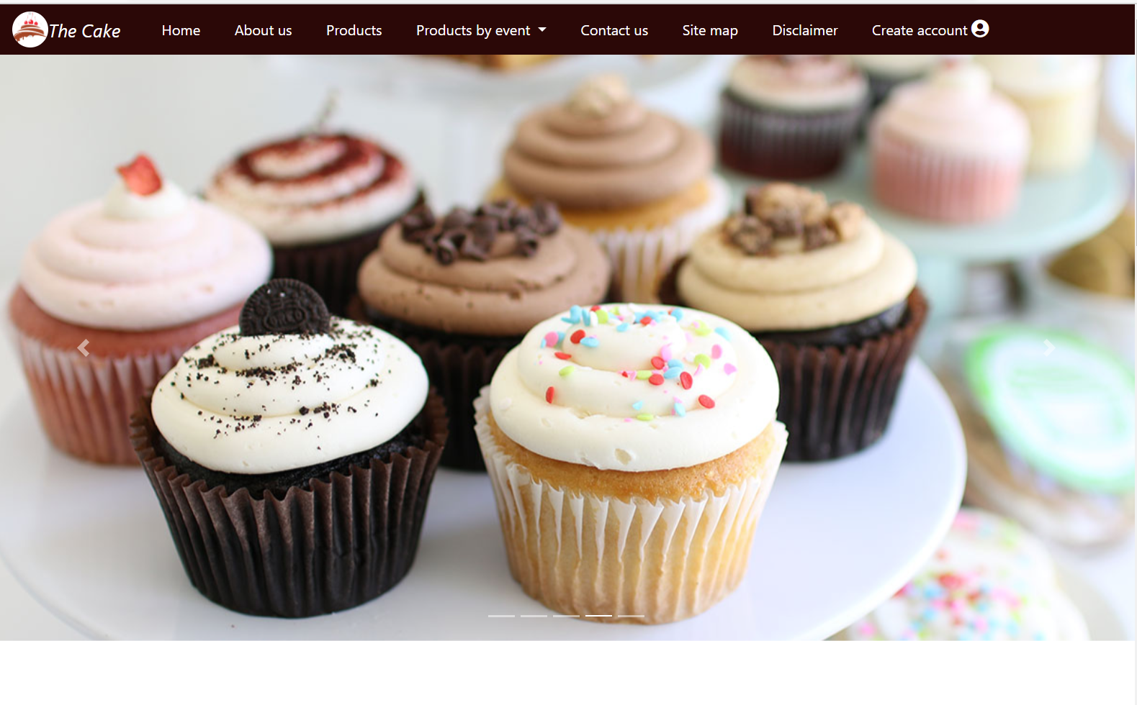

***Content***

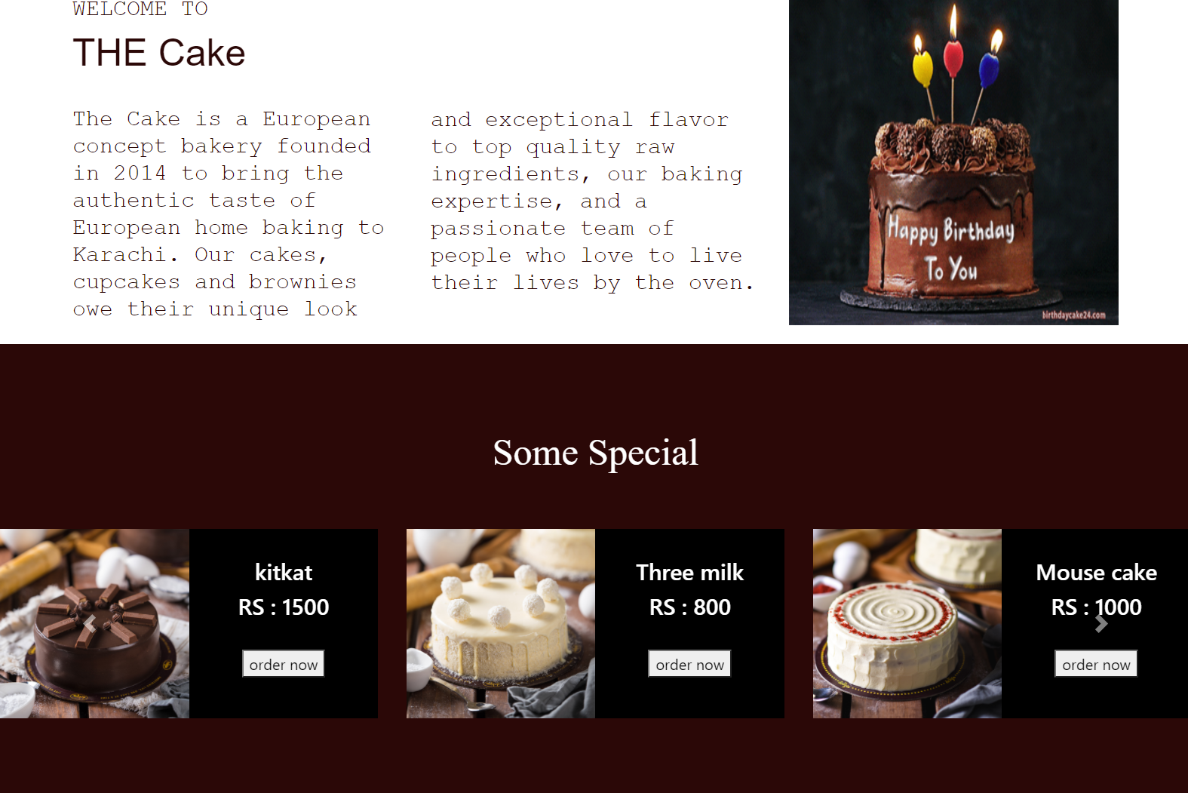

***footer***

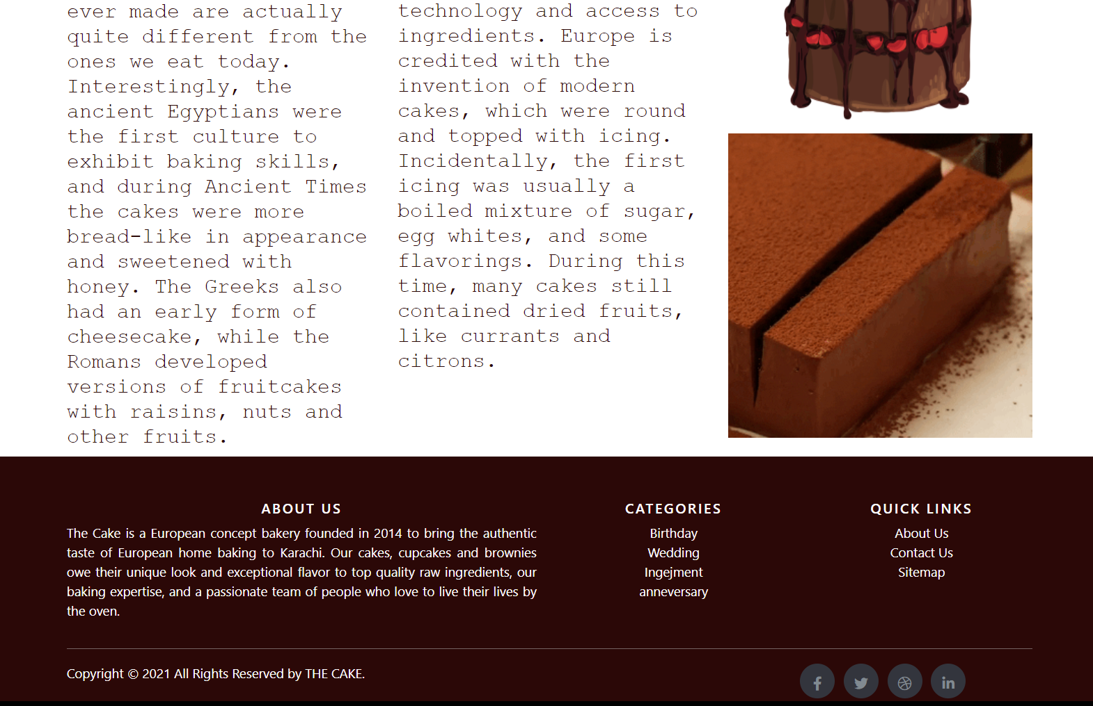

1. ***about us***

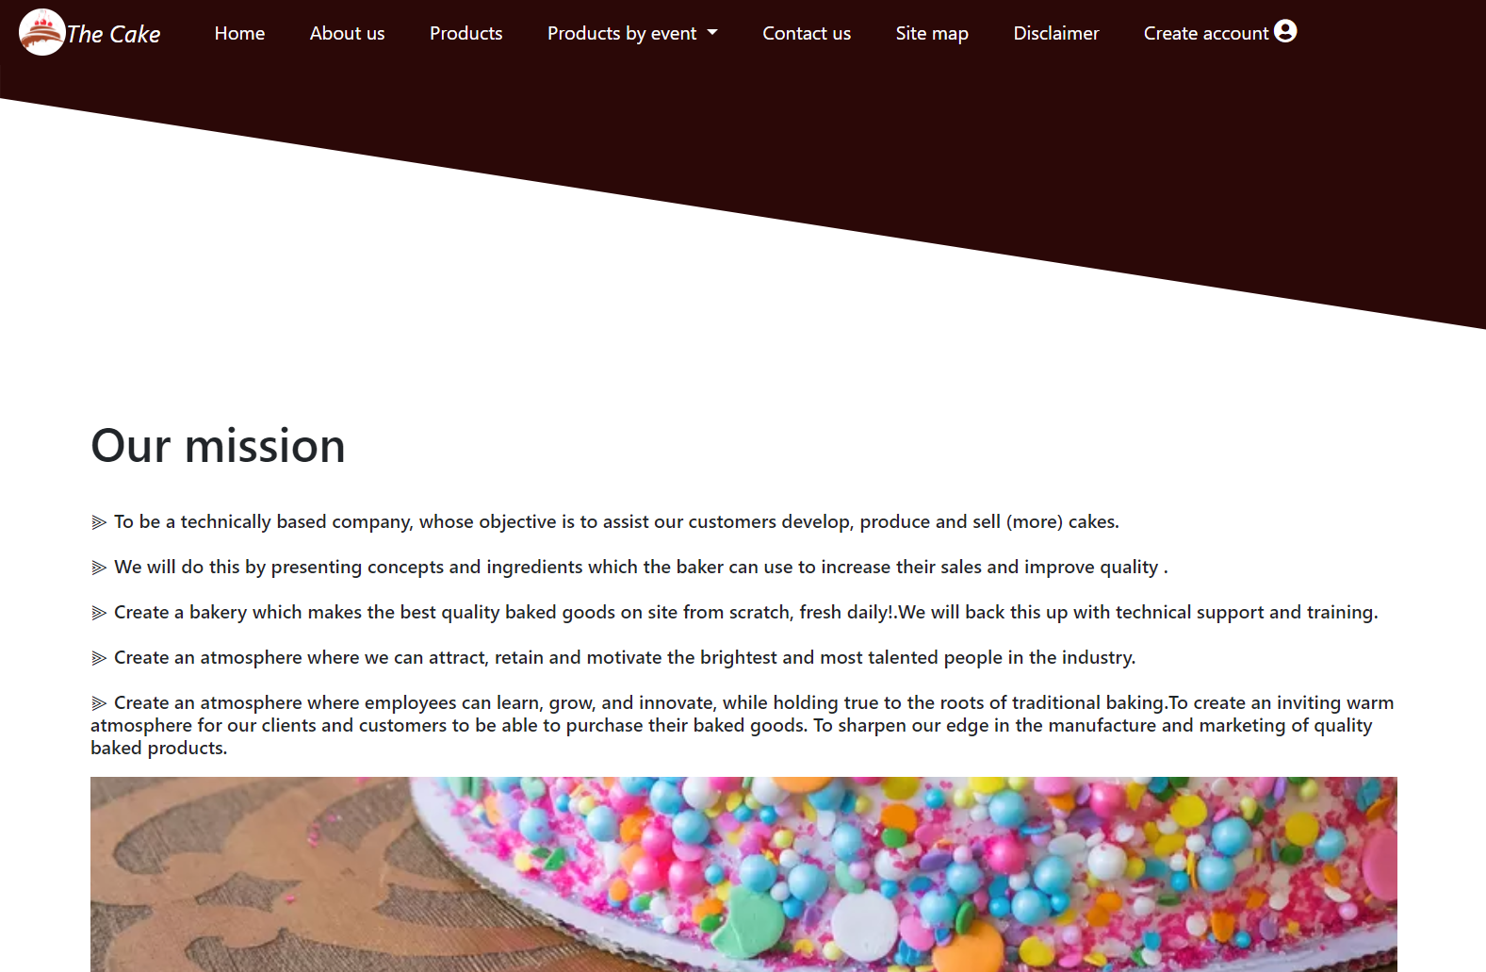

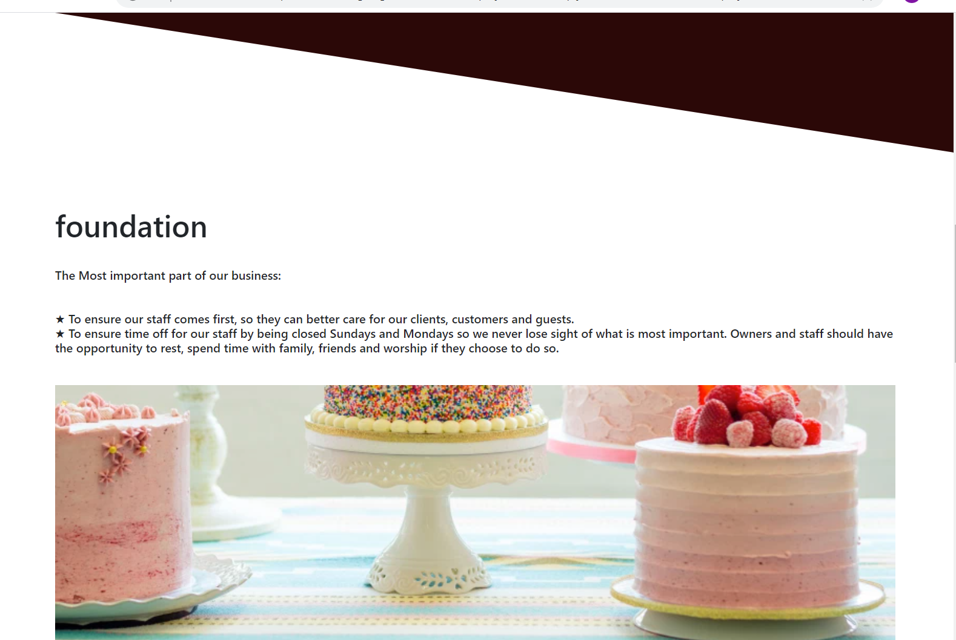

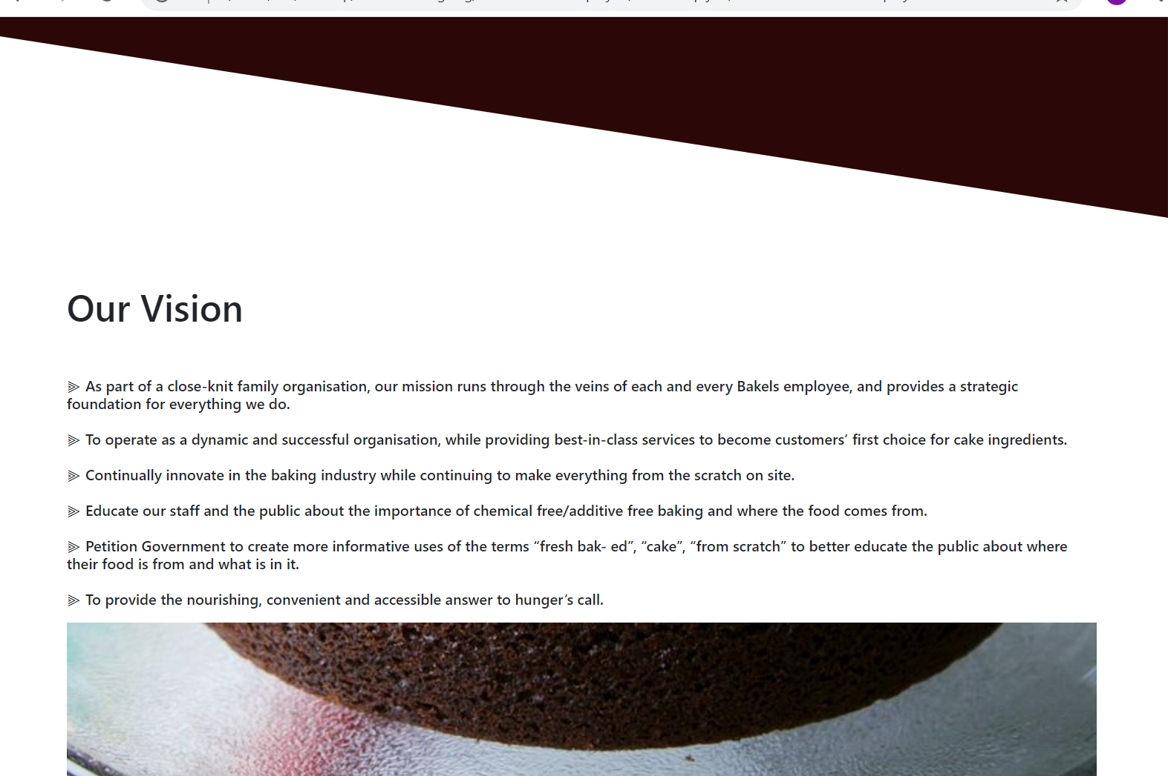

1. contact us

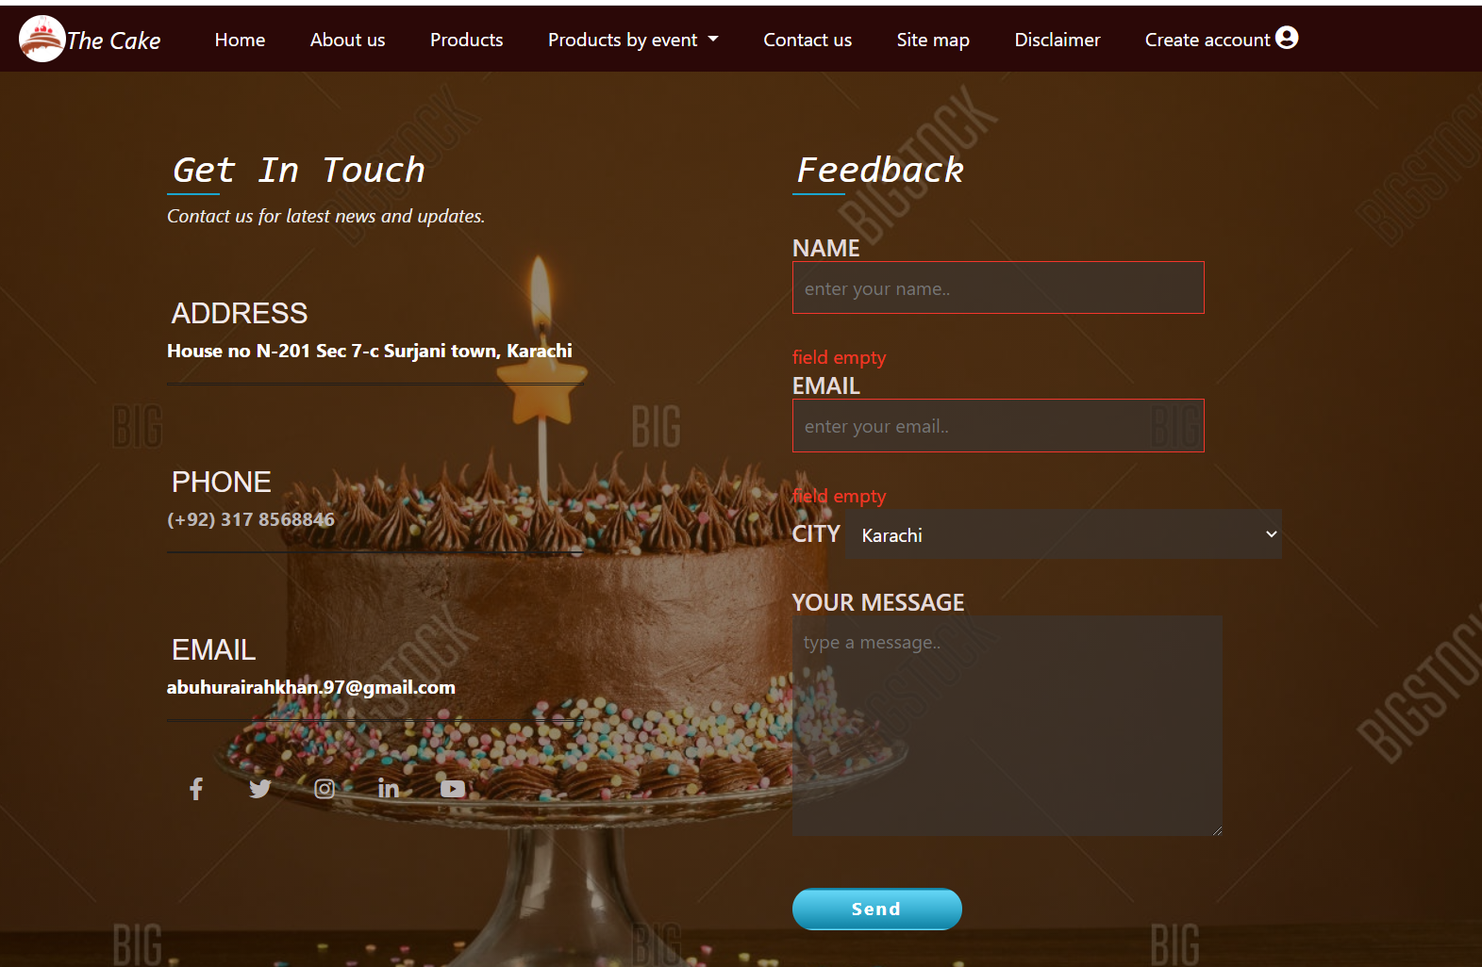

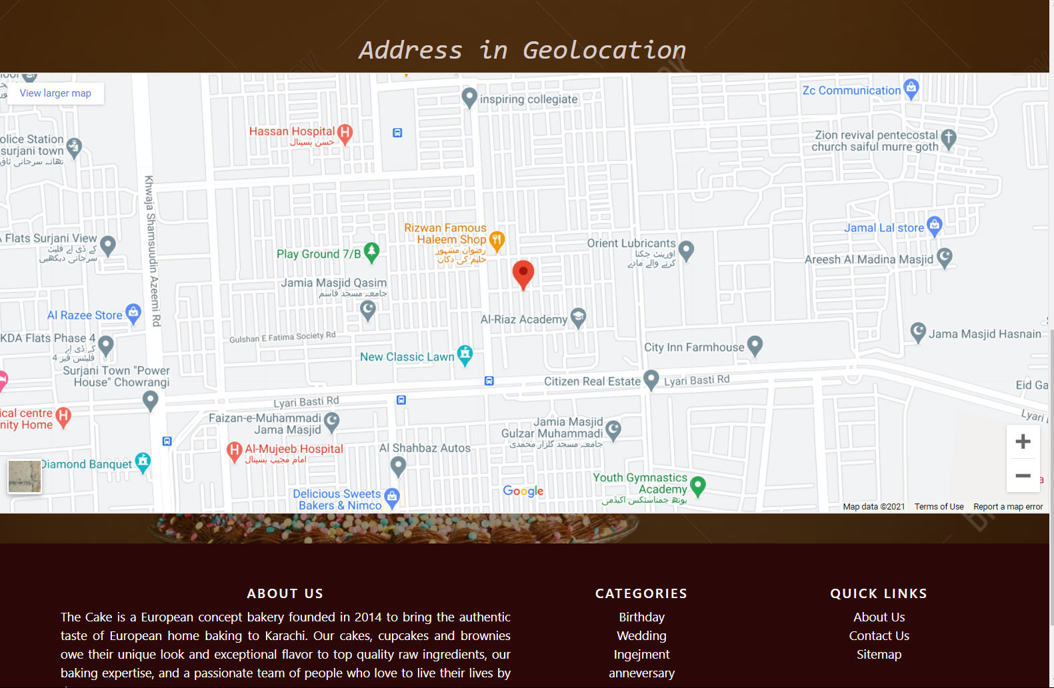

1. disclaimer

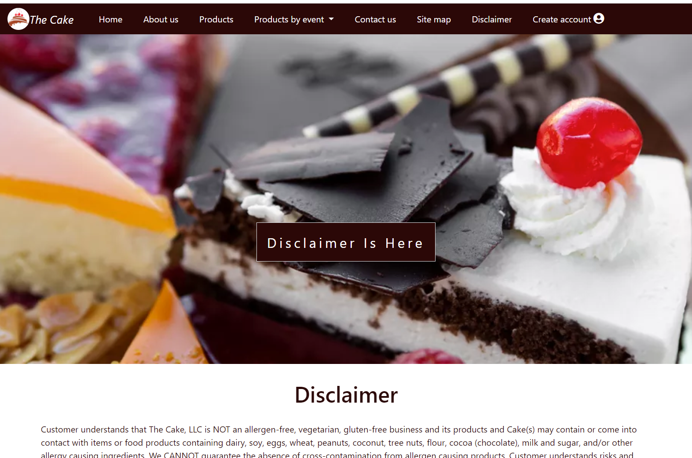

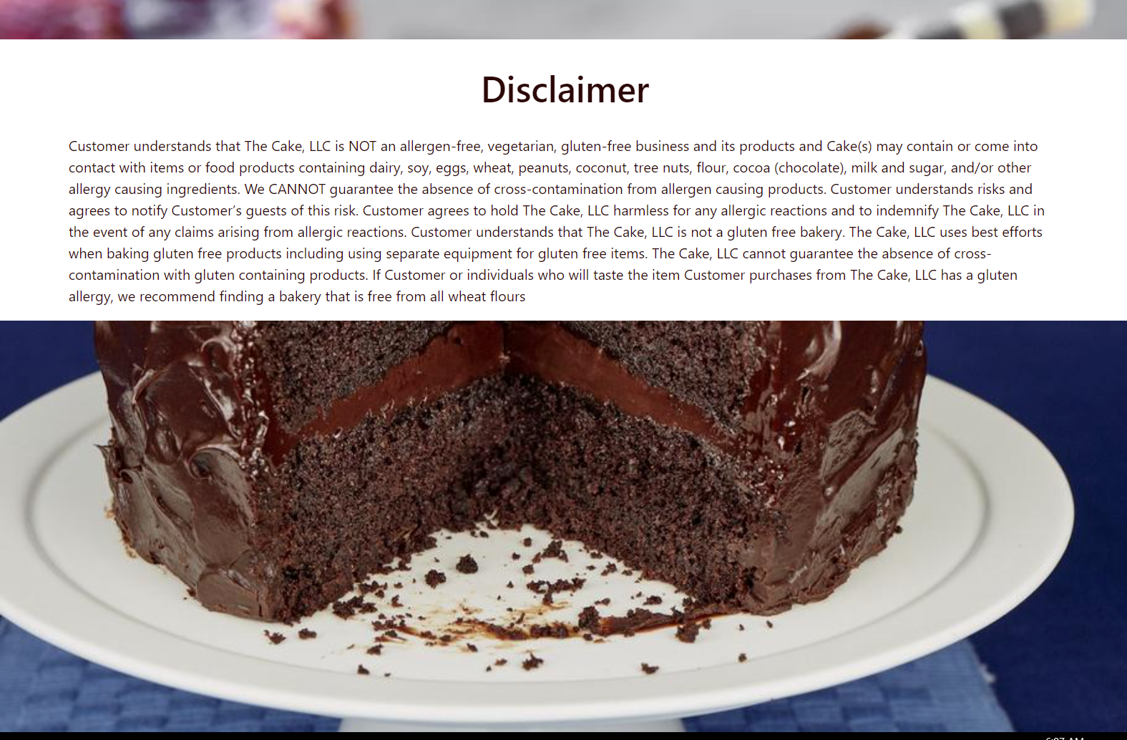

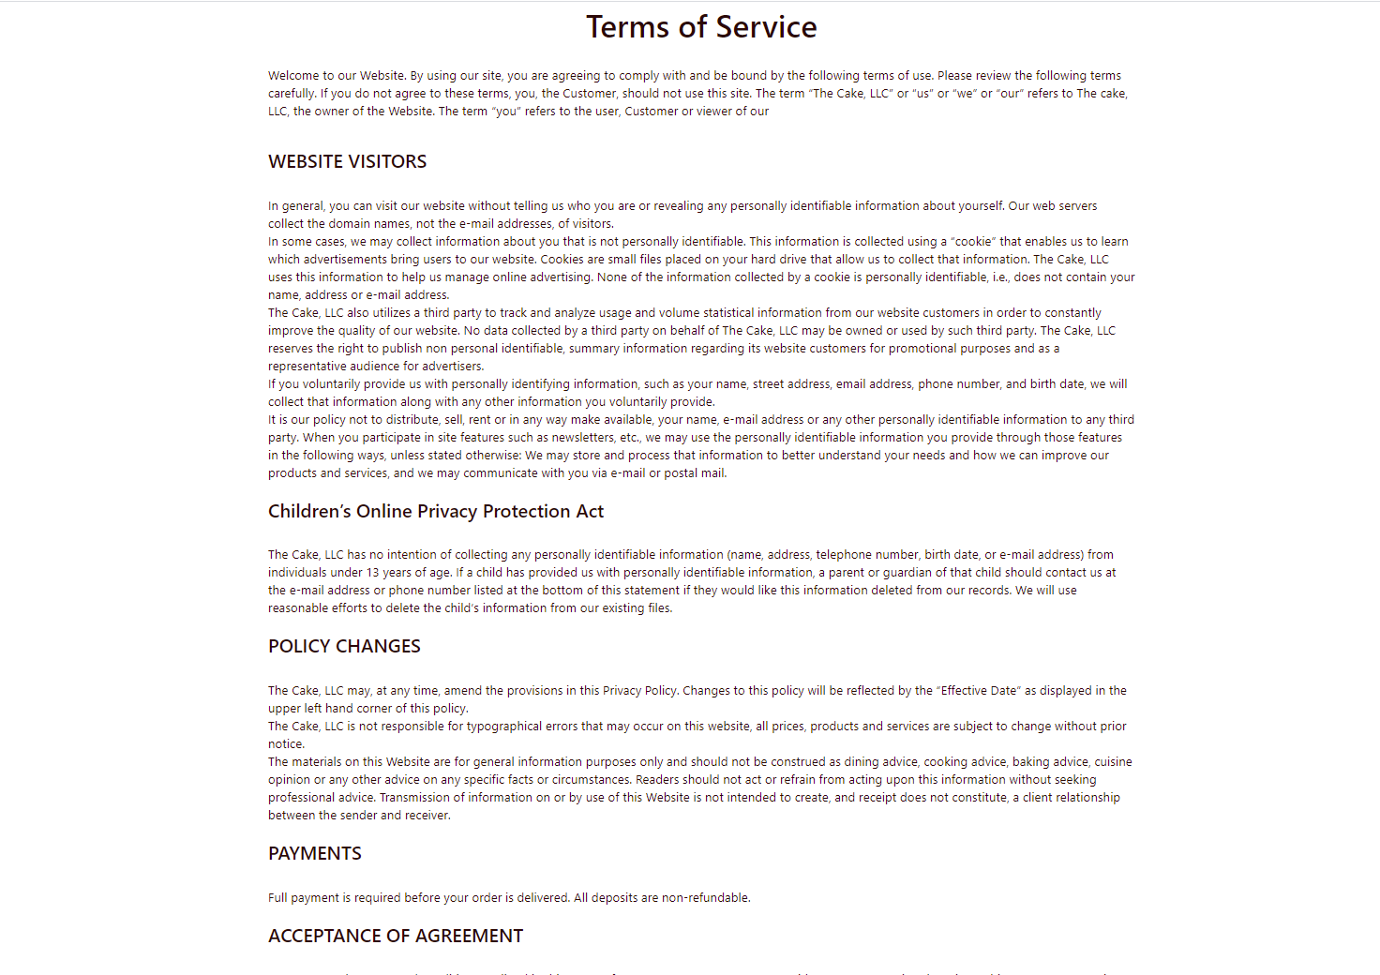

1. create account

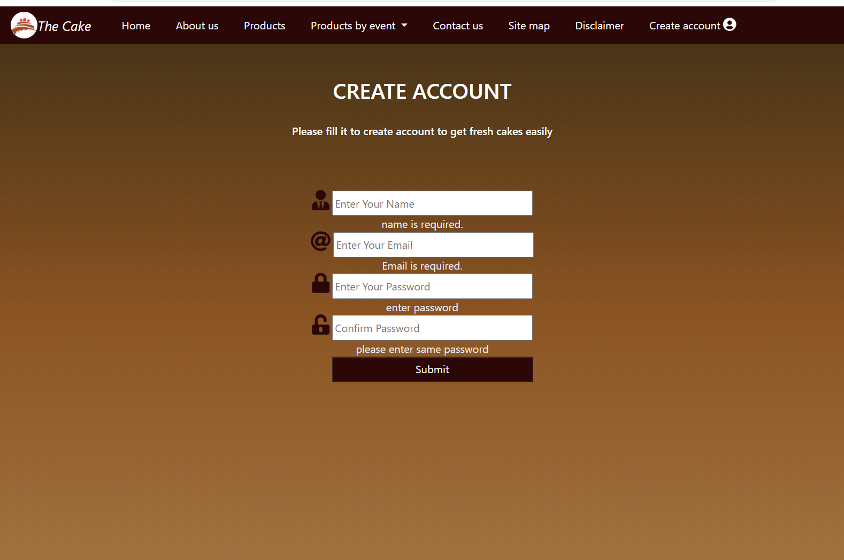

1. SITE MAP

